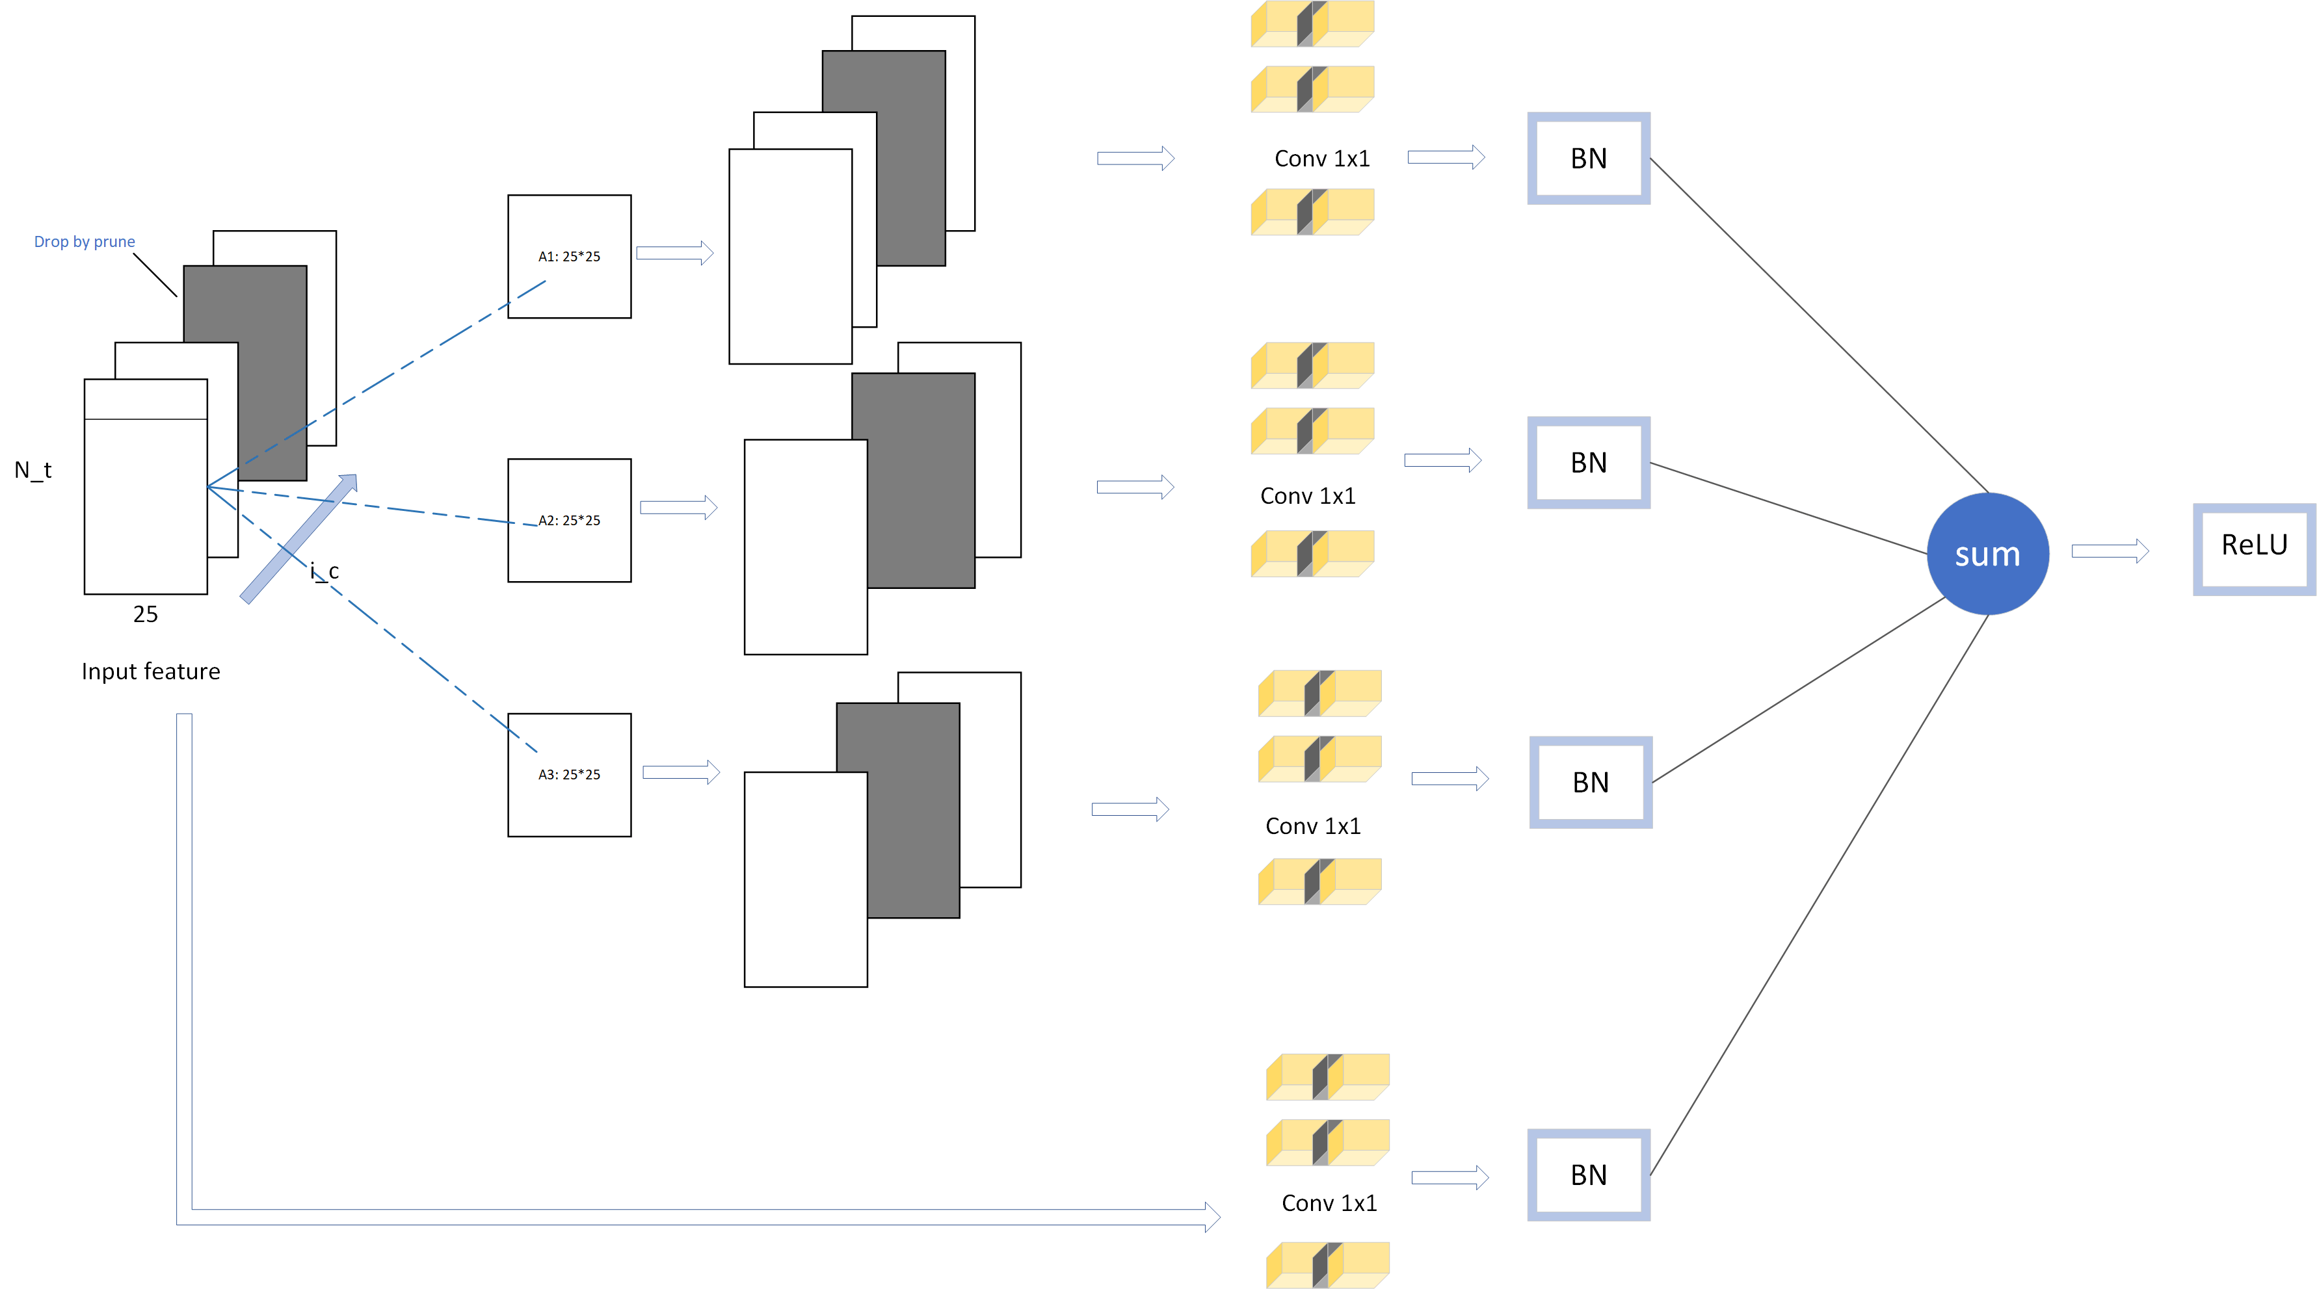

Conv1剪枝与数据流

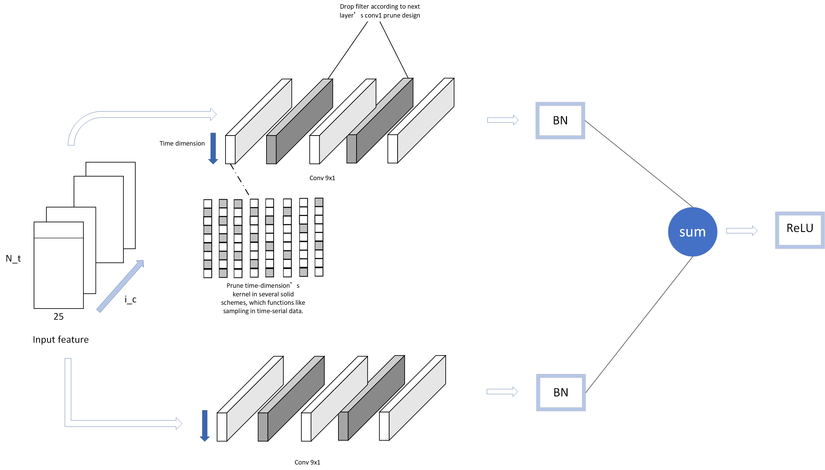

Conv9剪枝与数据流

剪枝前

剪枝后





剪枝精度及对比

|  |
| --- |
| 0.4 |
| 0.25 |
| 0.2 |
| 0.15 |
| 0.52 |
| 0.42 |
| 0.35 |
| 0.95 |
| 0.92 |
| 0.5 |